Quiz 1

1. Research and knowledge production involves a large commitment of time, effort and money, therefore it is most often done by individuals associated with large institutions.
True
False

2. Most of the information produced in the United States is funded by federal, state, or local governments.
True
False

3. The government is under an obligation to provide access to information it produces because?
it is mandated by the U.S. Constitution
the information was produced at taxpayer expense and therefore the government has an obligation to make it available to citizens
the FBI says so

4. Traditionally the federal government has made the information it produces available to the public through?
the Library of Congress
the Internet
the depository library system

5. Online access to government information is convenient but it also presents problems, chief among them is?
the inability to guarantee long term preservation of the material
publishing the material online is difficult
searching for the information is difficult

6. Research produced by faculty at research universities is most often published?
on the Internet
in general interest magazines
in books and scholarly journals

7. Faculty at universities do research because?
they are interested in a specific idea and want to find out more about it
there is a gap in the knowledge of a discipline and they want to develop a new theory
they want to update a specific area of knowledge with new information

8. Corporate laboratories and business research firms also perform research. However, unlike public sector agencies, corporations?
give their information away for free
keep most of their information secret
usually charge people money to use the information they do make public

9. In Brian Martin's article "The Politics of Research," he is critical of the fact that research funding is highly unequal across disciplines in universities. Which of the following university disciplines does Martin say are poorly funded?
Chemical Engineering
Computer Science
Philosophy
Biotechnology
Women's Studies
Creative Writing

10. Which of the following does Brian Martin consider failings of modern higher education, especially as it takes place at research universities?
knowledge is treated as a commodity, passively accepted and absorbed by student consumers
classroom experience is organized around the premise that learning results only from being taught by experts
knowledge is divided into narrow disciplinary boxes
performance in research takes precedence over commitment to teaching
knowledge and learning are divorced from social problems or channeled into professional approaches
competition prevails over cooperation

Tutorial Home Page

Quiz 2
1. Why is it difficult to catalog or index information so that people can easily locate it?
because cataloging and indexing is a subjective process and therefore allows for ambiguity
because it is difficult to anticipate how different people might search for information
because it is sometimes difficult to accurately interpret an author's meaning or intent

2. Library classification systems attempt to shelve books together by?
color
author
subject
year of publication

3. What are the two major classification systems used by libraries in the United States?
the Cutter Classification System
the Dewey Decimal Classification System
the American Library Classification System
the Library of Congress Classification System

4. Classification systems structure knowledge objectively and contain little cultural bias.
True
False

5. The Dewey Decimal Classification System organizes material based upon an underlying western philosophical structure while the Library of Congress Classification System uses a more pragmatic approach, organizing material based upon the needs of the Library of Congress.
True
False

6. It is relatively easy to update and make changes to library classifications systems.
True
False

7. The Dewey Decimal Classification System begins with letters and divides knowledge over 20 broad categories.
True
False

8. What is the purpose of subject heading systems?
they describe what a book or periodical article is about
they allow people to search for information by subject area
they assist searchers in understanding how a specific subject fits into the larger structure of knowledge
they provide insight into the meaning of life

9. The majority of libraries in the United States assign subject headings to books using?
Wilson Subject Headings
Library of Congress Subject Headings
ERIC Subject Headings
American Library Subject Headings

10. Most books and periodical articles receive more than one subject heading because?
librarians don't have better things to do with their time
most books and articles cover more than one subject
the more subject headings a book or article receives the more chances a searcher has to locate the item

11. Most periodical indexes do not use Library of Congress Subject Headings, instead they use their own subject headings.
True
False
Quiz 3

1. One of the most difficult aspects of writing a research paper is determining how narrow to focus your topic.
True
False

2. One way to help focus your research paper is to state your topic in the form of a question and isolate the key ideas or concepts. Other questions to ask yourself before you begin your research include?
What is the main idea of my paper?
What specific ideas am I trying to describe or prove?
What academic disciplines does my topic fit into?
What specific aspects of the topic do I wish to consider?

3. The majority of published information is now available online.
True
False

4. The advantages of searchng for information online include?
it is usually faster, especially when you search across multiple years
you can combine search terms
the information is updated more frequently
the information is more accurate

5. The disadvantages of searching for information online includes?
you often get an enormous number of search results, especially when using web search engines
you get a number of false hits, i.e., items that contain your keywords but do not match your topic
you always have to pay extra for the information

6. The advantages of searching for information using print indexes include?
they provide subject cross references to other related topics
the information is more accurate
they index material published prior to the invention of full-text online indexes

Quiz 4
1. Online library catalogs, electronic periodical indexes, and Internet search engines are all examples of databases.
True
False

2. The largest unit of a database is?
a record
a field
a subfield

3. Databases search for information using only the specific field which you specify at the beginning of the search.
True
False

4. The Internet is able to send information back and forth to different types of computers because of what software?
application software
operating system software
protocol software

5. The Internet is an example of a client/server model of computing. Client/server computer systems are characterized by which of the following?
server computers contain the information that client computers access
server computers run special software that organizes and manages the information
client computers are used by individuals to access the information on servers

6. The main software protocol that manages data on the Internet is?
HTTP
TCP/IP
FTP
POP

7. The World Wide Web, Email, Newsgroups, and Telnet are all subsystems of the Internet.
True
False

8. Most material published on the Internet has not gone through the editorial process, therefore you should take special care in determining its quality and authenticity.
True
False

9. Yahoo! is an example of a Web?
search engine
directory
catalog

10. Yahoo! is organized into subject categories which allow you to browse similar to a print index.
True
False

11. One way to limit your search results in Web directories and search engines so that the results better reflect your topic is to use phrase searching. To search for words as a phrase you do what?
put question marks around the words
put asterisks around the words
put quotation marks around the words

12. Truncation, or wild card searching, allows you to locate words with variations in spelling and with different endings. To perform truncation searching in most Web Search Engines you use which one of the following symbols?
# (pound symbol)
* (asterisk symbol)
+ (plus symbol)
& (ampersand symbol)

13. Electronic library catalogs and periodical indexes are different from Web search engines because?
computers not humans do the cataloging and indexing of the information
they catalog and index material that has gone through an editorial and publishing process
they include only material that has been selected by a librarian or indexer
they can be searched by subject headings that have been assigned by a librarian or indexer

14. Many modern library catalogs allow you to search for books, videos, sound recordings, etc., by which of the following?
author
title
keywords
subject headings

15. Some libraries catalog Web sites on their library catalog just like they do books.
True
False

16. The Minnesota State College and University System is a member of the PALS library system. The PALS system consists of more than 80 libraries in the state of Minnesota, North and South Dakota. Other members of PALS include?
private college and university libraries
the University of Minnesota
state agency libraries
special libraries

17. When you perform an author search in a library catalog you type the author's first name followed by the author's last name.
True
False

18. PALS allows you to perform two types of title searches, e.g., Title Keyword and Title Exact. When would you most likely use a Title Keyword search?
when you don't remember the exact title of a book
when you are trying to locate a book on a specific subject
when the title of the book is very long

19. When performing an exact title search you leave out the initial article of the title ("a," "an," or "the").
True
False

20. When searching for information on a specific topic you can choose to search PALS by keyword, subject keyword, or subject exact. Keyword searching is the broadest type of search that you can do in PALS. When you request that PALS perform a keyword search, it searches which of the following fields?
author
title
note
call number
subject heading

21. If you choose to do a subject heading exact search in the PALS Library Catalog you must know?
the exact Dewey Decimal classification number
the exact Wilson subject heading
the exact Library of Congress subject heading

22. In the PALS databases you perform a truncation search by using what symbol?
* (asterisk)
+ (plus sign)
# (pound sign)
& (ampersand)

23. The PALS General Magazine Database informs you if your library owns a specific periodical. Which field in the database record informs you that you library does, or does not, own the periodical?
the Library field
the Location field
the Citation field

24. How do you know if the full text of a periodical article is available online in the PALS General Magazine database?
there is an asterisk * next to the date in the results list
the phrase "full text available" appears in the citation field
a "View Article" button appears at the top of the article record

25. The purpose of the periodical article abstract is to summarize the main ideas of the article.
True
False

Quiz 5
1. Print periodical indexes perform the same basic functions as online periodical indexes, i.e., they index articles in magazines and journals.
True
False

2. Which of the following are true statements?
most print indexes are published in yearly volumes, therefore you are limited in search for information one year at a time
most print indexes include the full text of the articles in the index
print indexes help you see how a subject fits into a field of knowledge by using cross-references and subheadings
print indexes allow for a greater degree of serendipity then do electronic indexes

3. In general print periodical indexes provide better information about their editorial policies and usage then do electronic periodical indexes.
True
False

4. Which of the following statements are true?
individual indexes only include a small subset of the magazines and journals produced in the world
no library subscribes to all the magazines and journals listed in their periodical indexes
some periodical indexes cover only specific subject areas while others are designed as general in scope

5. If you were looking for popular information about recent political events in the United States, which of the following indexes would you use?
General Science Index
Social Science Index
Reader's Guide to Periodical Literature

6. If you were looking for a movie review of a Hollywood movie, which of the following indexes would be the best to use?
Alternative Press Index
Readers' Guide to Periodical Literature
Social Science Index

7. If you were interested in locating scholarly criticism about novels authored by James Joyce, which index would be best to use?
Readers' Guide to Periodical Literature
Social Science Index
Humanities Index
General Science Index

8. If you were interested in locating scholarly research on political issues related to the global economy, which of the following indexes would be appropriate?
Readers' Guide to Periodical Literature
Social Science Index
General Science Index
Alternative Press Index

9. If you were interested in doing research on the genetic structure of human DNA, which one of the following indexes would you use?
Social Science Index
Readers' Guide to Periodical Literature
General Science Index
Alternative Press Index

10. Encyclopedias are often good places to begin your research because they provide you helpful background information on a topic and are written with the lay reader in mind.
True
False

11. Unlike general encyclopedias which attempt to cover all areas of knowledge, subject encyclopedias provide in-depth coverage of a specific field of study. Subject encyclopedias are especially appropriate for undergraduate research because?
the articles are written by scholars
they often provide bibliographies to additional resources
they are approved by the National Education Association

12. Encyclopedias are usually located in what part of the library?
circulating collection
reference collection
index tables

13. A quick way to locate all the encyclopedias a library owns is to use the library catalog. Which one of the following searches would be the most effective to locate all the encyclopedias that your library owns?
a title search using the search term encyclopedia
a keyword search using the search term, encyclopedia#
a subject search using the term, encyclopedia

14. What is the difference between an abridged and an unabridged dictionary?
an abridged dictionary contains all the "officially recognized" words in a language while an unabridged dictionary contains only the most common words
an abridged dictionary bridges the gap between the different meanings of a word while an unabridged dictionary does not
an unabridged dictionary contains all the "officially recognized" words in a language while an abridged dictionary contains only the most common words

15. In addition to providing the definition of a word, an etymological dictionary such as the Oxford English Dictionary, also provides?
a history of the word
the date when the word first entered the language
examples of how the word has been used through time

16. Why would you seek out a book length bibliography before you begin your research?
book length bibliographies are produced by subject experts and provide access to many of the major works in a field of study
book length bibliographies make the research process easier because they allow you to search library catalogs and periodical databases for specific authors and titles of works
book length bibliographies make you familiar with the major authors in a field of study

Quiz 6

1. Under the fair use exemption to copyright law a person is allowed to make a copy of a periodical article for personal use, however, it is illegal to make multiple copies of the article for other people to use.
True
False

2. Fair use attempts to balance the economic and intellectual property rights of an author with the rights of others to use the work for educational and personal nonprofit purposes.
True
False

3. The intended purpose of copyright law is?
to provide an author or publisher with the incentive to produce a work by granting them a limited monopoly over the use of the work
to dissuade other people from plagiarizing the work
to make authors rich
to make sure that authors and publishers make a fair return on the investment of time and money that they have put into the creation of a work

4. Why should libraries provide access to a wide variety of ideas and knowledge?
to make sure that the public has free access to multiple viewpoints on an issue
to make sure that citizens of a democracy are well informed on issues that affect their lives
to reflect the diversity of people that the library serves
to push a specific political agenda of the library staff or the community

5. What are some of the censorship issues that currently confront libraries?
attempts to ban children's books presenting gay and lesbian headed families
attempt to remove children's fiction books dealing with themes of magic from school and public libraries
attempts to put Internet filtering software on public library computers

Quiz 7
This quiz is quite difficult. You must get the citation exactly right. A period or comma out of place, or a uncapitalized word will result in a wrong answer. For help you can consult the MLA citation lesson in the Tutorial.
1. Create a citation for the following book using MLA format. Create the citation as it would be used in your List of Works Cited. 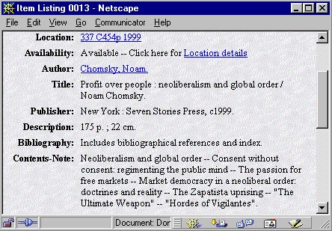
Bottom of Form
2. Create a citation for the following encyclopedia article using MLA format. Create the citation as it would be used in your List of Works Cited. (The article "Agricultural Ethics" is taken from volume 1 of the Encyclopedia of Applied Ethics.)
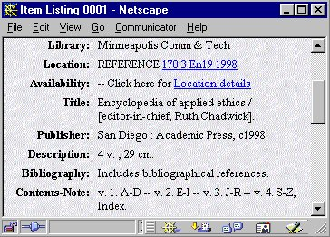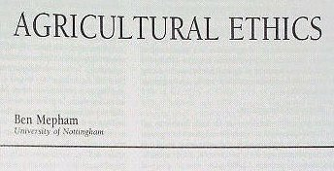

Enter your answer here:
Create a citation for the following magazine article using MLA format. Create the citation as it would be used in your List of Works Cited. (The Nation is a popular alternative news magazine that is published weekly. This article is located on pages 87 through 88. In the title field you see (US Constitution). This is an explanatory note and is not included in your citation.)
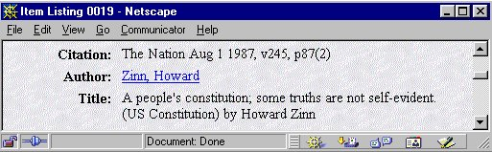

Enter your answer here:

Create a citation for the following scholarly journal article using MLA format. Create the citation as it would be used in your List of Works Cited. (This article is from a scholarly journal with continuous pagination. The article is 13 pages long, running from page 540 through page 553.)
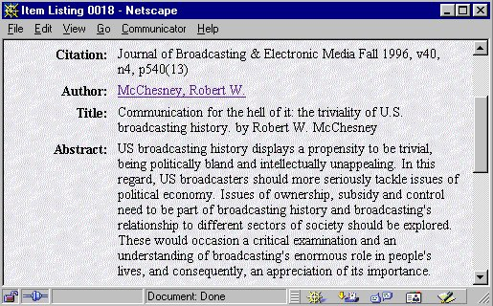

Enter your answer here:

Create a citation for the following web page using MLA format. Create the citation as it would be used in your List of Works Cited. (This is about as straightforward a web page as you are likely to find. It has all the traditional aspects of a print resource. Many web pages don't provide you with all this information.)
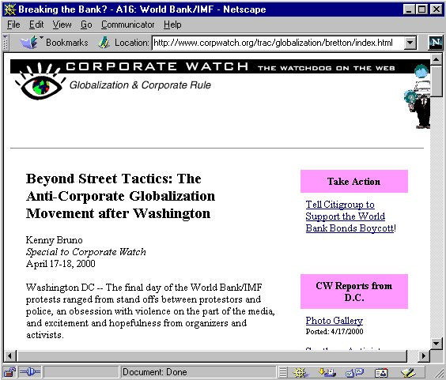

Enter your answer here:

Answers to Quizzes
PALS = Prairie Area Li brary System
Numbers | Quiz 1 | Quiz 2 | Quiz 3 | Quiz 4 | Quiz 5 | Quiz 6
1 | true | Top of Form  because cataloging and indexing is a subjective process and therefore allows for ambiguity  because it is difficult to anticipate how different people might search for information  because it is sometimes difficult to accurately interpret an author's meaning or intent  Bottom of Form | true | true | true | True  THAT'S RIGHT!!! The fair use exemption allows you to make a copy of an article for personal use. However, it is not legal for you to make multiple copies of the article for others to use. This is why your instructor cannot make copies of magazine articles to hand out to everyone in class. As a result your instructor puts a copy of the article on reserve in the library.
2 | true | subject | Top of Form  What is the main idea of my paper?  What specific ideas am I trying to describe or prove?  What academic disciplines does my topic fit into?  What specific aspects of the topic do I wish to consider?  Bottom of Form | record | Top of Form  most print indexes are published in yearly volumes, therefore you are limited in search for information one year at a time  print indexes help you see how a subject fits into a field of knowledge by using cross-references and subheadings  print indexes allow for a greater degree of serendipity then do electronic indexes  Bottom of Form | True  AT'S RIGHT!!! The fair use exemption is an attempt to balance the intellectual property rights of an author/publisher and the needs of researchers to use works without putting an unduly burdensome economic barrier in their way.
3 | the information was produced at taxpayer expense and therefore the government has an obligation to make it available to citizens | LCCS and DDCS | false | true | true | Top of Form  to provide an author or publisher with the incentive to produce a work by granting them a limited monopoly over the use of the work  to dissuade other people from plagiarizing the work  to make sure that authors and publishers make a fair return on the investment of time and money that they have put into the creation of a work  Bottom of Form  THAT'S RIGHT!!! The intent of copyright law is to encourage the production of more knowledge by allowing authors and or publishers a fair return on their investment by granting them a limited monopoly on the work. However, the rights of the author and publisher must be balanced with the rights of the reader to use the work. The fair use exemption attempts to provide limited access to a work without additional charge.
4 | the depository library system | false | it is usually faster, especially when you search across multiple years  you can combine search terms  the information is updated more frequently | Protocol software | individual indexes only include a small subset of the magazines and journals produced in the world  no library subscribes to all the magazines and journals listed in their periodical indexes  some periodical indexes cover only specific subject areas while others are designed as general in scop | to make sure that the public has free access to multiple viewpoints on an issue  to make sure that citizens of a democracy are well informed on issues that affect their lives  to reflect the diversity of people that the library servesTHAT'S RIGHT!!! All libraries have an educational mission and should provide access to knowledge that reflects a diversity of opinion. This diversity should reflect the community that the library serves and provide citizens with a wide breath of opinion that will assist them in making informed political decisions. However, the library should not overtly push a narrow staff or community agenda in its collection policy.
5 | the inability to guarantee long term preservation of the material | true | you often get an enormous number of search results, especially when using web search engines  you get a number of false hits, i.e., items that contain your keywords but do not match your topic | Top of Form  server computers contain the information that client computers access  server computers run special software that organizes and manages the information  client computers are used by individuals to access the information on servers  Bottom of Form | Reader's Guide to Periodical Literature | Top of Form  attempts to ban children's books presenting gay and lesbian headed families  attempt to remove children's fiction books dealing with themes of magic from school and public libraries  attempts to put Internet filtering software on public library computers  Bottom of Form
6 | in books and scholarly journals | false | Top of Form  they provide subject cross references to other related topics  the information is more accurate  they index material published prior to the invention of full-text online indexes  Bottom of Form | TCP/IP  THAT'S RIGHT!!! TCP/IP (Transaction Control Protocol/Internet Protocol) is the main protocol that manages information on the Internet. HTTP manages information on the World Wide Web. FTP manages file transfers. POP is an email protocol. | Readers' Guide to Periodical Literature
7 | they are interested in a specific idea and want to find out more about it  there is a gap in the knowledge of a discipline and they want to develop a new theory  they want to update a specific area of knowledge with new information | false |  | true | Humanities Index
8 | keep most of their information secret  usually charge people money to use the information they do make public | they describe what a book or periodical article is about  they allow people to search for information by subject area  they assist searchers in understanding how a specific subject fits into the larger structure of knowledge |  | true | Top of Form  Social Science Index  Alternative Press Index  Bottom of Form
9 | Philosophy  Women's Studies  Creative Writing | LCSH |  | directory | General Science Index
10 | Top of Form  knowledge is treated as a commodity, passively accepted and absorbed by student consumers  classroom experience is organized around the premise that learning results only from being taught by experts  knowledge is divided into narrow disciplinary boxes  performance in research takes precedence over commitment to teaching  knowledge and learning are divorced from social problems or channeled into professional approaches  competition prevails over cooperation | most books and articles cover more than one subject  the more subject headings a book or article receives the more chances a searcher has to locate the item |  | true | true
11 | true |  |  | put quotation marks around the words | the articles are written by scholars  they often provide bibliographies to additional resources
12 |  |  |  | * (asterisk symbol) | reference collection
13 |  |  |  | they catalog and index material that has gone through an editorial and publishing process  they include only material that has been selected by a librarian or indexer  they can be searched by subject headings that have been assigned by a librarian or indexer | a keyword search using the search term, encyclopedia#
14 |  |  |  | Top of Form  author  title  keywords  subject headings  Bottom of Form | an unabridged dictionary contains all the "officially recognized" words in a language while an abridged dictionary contains only the most common words
15 |  |  |  | true | Top of Form  a history of the word  the date when the word first entered the language  examples of how the word has been used through time  Bottom of Form
16 |  |  |  | Top of Form  private college and university libraries  state agency libraries  special libraries  Bottom of Form | Top of Form  book length bibliographies are produced by subject experts and provide access to many of the major works in a field of study  book length bibliographies make the research process easier because they allow you to search library catalogs and periodical databases for specific authors and titles of works  book length bibliographies make you familiar with the major authors in a field of study  Bottom of Form
17 |  |  |  | false
18 |  |  |  | Top of Form  when you don't remember the exact title of a book  when the title of the book is very long  Bottom of Form
19 |  |  |  | true
20 |  |  |  | Top of Form  author  title  note  subject heading
21 |  |  |  | the exact Library of Congress subject heading
22 |  |  |  | # (pound sign)
23 |  |  |  | the Location field
24 |  |  |  | Top of Form  Top of Form  there is an asterisk * next to the date in the results list  a "View Article" button appears at the top of the article record  Bottom of Form
25 |  |  |  | true

